**IP version six within AWS.**

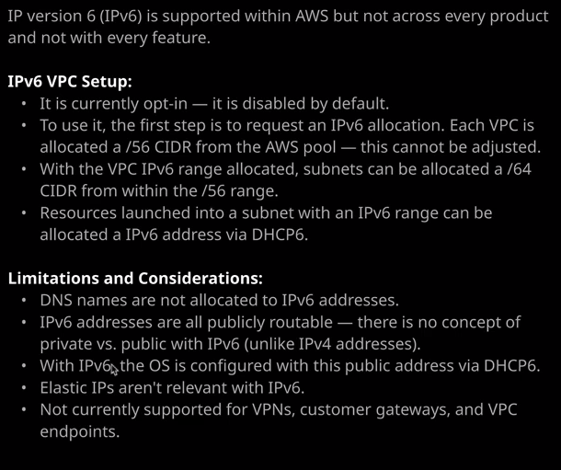

Now at an associate level for the solutions architect associate exam, you really only need to be aware that **IP version six is an option, that it's not enabled by default,** and the really high level steps required to enable it. So that's all I'm going to cover in this lesson. You really don't need to be aware of exactly how it functions at the associate level. Now**, IP version six is not supported across every AWS product and service.** So you need to be quite careful if you're going to use it for production usage but if you do want to use it enabling it has a number of independent steps.

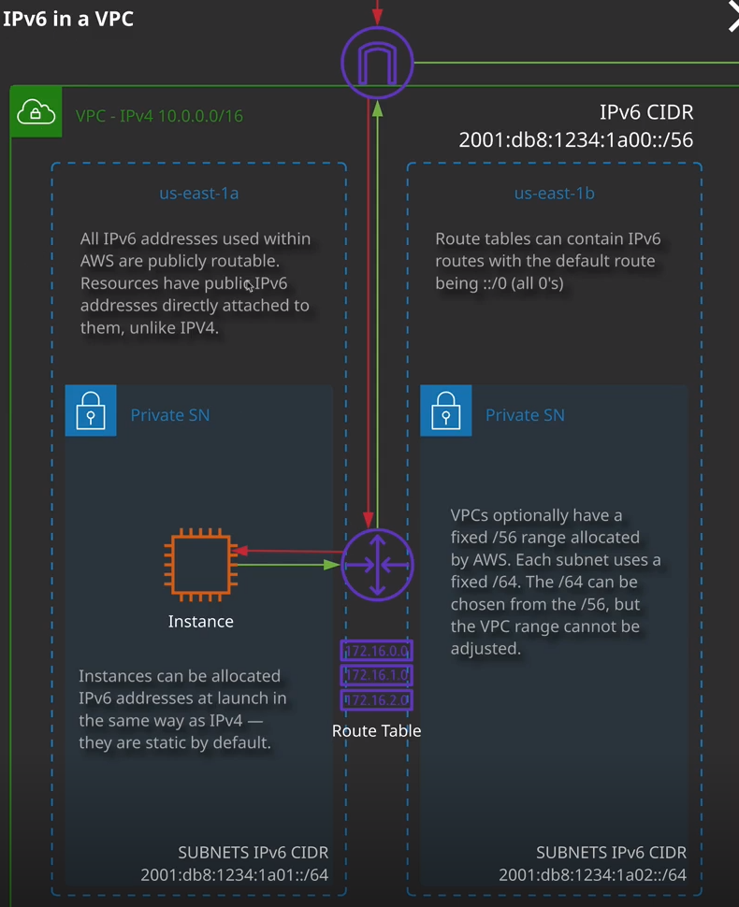

Now, this is the architecture of how IP version six works within a VPC. Essentially, what you need to do is enable IP version six for the entire VPC and when you do that, **you're allocated a /56 IP version six CIDR range. You don't get to pick that range, and you can't adjust it.** It's allocated by AWS. So in this case, if I selected VPC1, I went to actions, and then edit CIDRs, and then under VPC IP version six a clicked on ad IPv6 CIDR then I will be associated a /56 range that I couldn't choose. It's simply allocated by AWS and that's the first step to enabling IP version six to any AWS employment is to enable an IP version six CIDR range on the VPC itself.   
Okay, so that's step one and the **next step is that you need to subnet this range up and allocate subsets of that range to individual subnets.** So I'm going to go ahead and click on subnet. I'm going to select one of the public subnets that's inside of VPC1 and I'm going to go ahead and select public A, which is the subnet that the bastion host is in. I'm going to go to actions and then edit IP version six CIDR, click add IP version six CIDR, and just enter double zero. So this is the base network range inside this /56 range and it's carving it up into /64 ranges. So the first one is 00. I'm going to go ahead and hit save. Now, at this point, this subnet now has a valid IP version six CIDR range and it's 2600:1F18:633C:E000. So this is actually the IP versions CIDR now that is a subset of the one that the VPC has, and now this subnet is fully enabled for IP version six.

Now, at this point, there are a number of other things that you need to enable for this to work flawlessly. So we would need to go to the **route tables**. In this case, select the public route table and go to routes. At this point, we only have an IP version four default route, so I need to go to edit routes, add a route and then the IP version six equivalent of this 0000/0 is ::/0 that's the default route for IP version six and again to allow any instances public connectivity we need to select this drop down, go to Internet Gateway, select the Internet Gateway for this VPC, and hit save. It's worth knowing that **Internet Gateways fully support IP version four and IP version six but for IP version six every IP version six address is fully publicly routable**. So you don't have this concept, at least in AWS, of private addresses and public addresses. For IP version six, every address that you're assigned is publicly routable. You'd also need to give the same consideration to NACLs or security groups, which you'd also need to edit and add any appropriate IP version six rules. So remember at the moment the security groups and network ACLs are going to be configured for IP version four and so you'll need to add entries onto your NACL if appropriate, or on to your security group to allow connectivity using IP version six. Now that is beyond the scope of what you need at an associate level. That's more for the networking specialty certification but just for the solutions architect associate know **that you also need to edit security groups and network ACLs.**

At this point, that's all the configuration required, so you could go ahead and launch an instance into an IP version six enabled subnet. You just need to make sure that you're using an instance which can support IP version six and an operating system, which also has IP version six support. All of the modern instance types and current generations of AMIs fully support IP version six. So I could select this instance, go to configure instance details, and then I could perform any specific configuration I wanted either auto assigning IP version six address or adding one specifically, and that's really all there is to it. There are considerations which you do need to keep in mind, so DNS names are not allocated to IP version six addresses. All IP version six addresses are publicly routable. There's no concept of private or public with the IP version six. With IP version six, and this is critical to understand, remember how with an IP version four public address, the operating system itself so Windows or Linux does not have the public address configured. That's the responsibility of the internet gateway to map these private addresses onto the public ones. Well, with IP version six, the operating system itself is configured with the proper IP version six address, which is publicly routable and this process happens using DHCP six, it's automatically configured and so all the internet gateway really is doing for IP version six is routing from your VPC to the public internet. It's not doing any of that static NAT process. That's not a process supported with IP version six. Now IP version six, at the time of creating this lesson, it's not fully supported. So it's not supported for VPNs, customer gateways, VPC endpoints, and various other different AWS services so be careful with that. It's not really ready for prime time usage. There are a lot of prerequisites that you need to keep in mind when using IP version six. It's something that's going to become more and more important over the next few years, but right now it is optional. It's not enable by default, and it does have significant limitations.

Now, in the next lesson, I'm going to be talking about a different service that's available inside AWS called the egress only internet gateway because IP version six addresses are all publicly routable and because IP version six has a much larger address range the whole process of NAT or network address translation is not required. Remember, **a NAT gateway serves two useful functions. The first is it let's lots of instances access the internet using a single public IP address, but it also prevents connections from the public internet being initiated to a private instance.** In the case of IP version six, because the IP addresses are all publicly routable by default, if you use this with an internet gateway then your instance is by default publicly accessible, the egress-only internet gateway provides an answer to that because it allows connectivity in an outbound only way from IP version six machines to the public internet but we'll talk about that much more in the next lesson.